1. Rewrote expressions such as f1, as f(1).
2. Fixed the 3rd-degree Maclaurin polynomial. The correct form:
$$M_{3}\left(x\right)= 1 + x -\frac{x^{3}}{3}$$

3. Tested the value of x in M3(x) and T3(x) That us the first test of my approximation.

1. I also added a better prediction about M3(x) and T3(x) approximations. T3(x) is accurate at x = 2 with less error but M3(x) is accurate at x = 0.

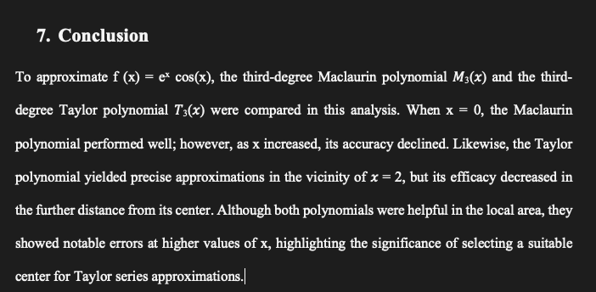

1. I also attached the PDF to my work assignment separately since I could not attach it to the Word file.
2. I also added the graphs for errors of both polynomials together for readability and conciseness.

1. I also added a new section in the conclusion where I discuss the results, particularly the two polynomials. A black and white text

   Description automatically generated